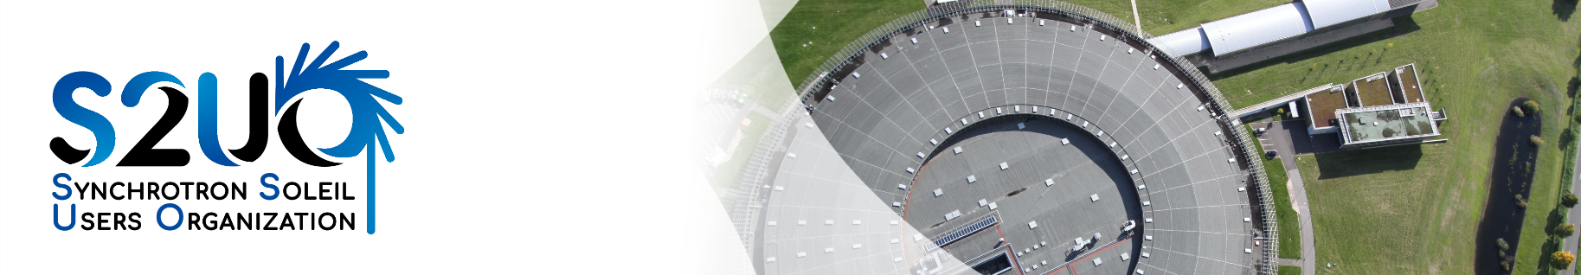

Policy statement
To send before April 6th, 2025

Name, Surname
Click or tap here to enter text.

Title and laboratory
Click or tap here to enter text.

I would like to stand for election in order to represent the following community:
Choose an item.

Describe in few lines your scientific activity related to synchrotron radiation.
Click or tap here to enter text.

Also a few words on your intended future action in the representative committee.
Click or tap here to enter text.

