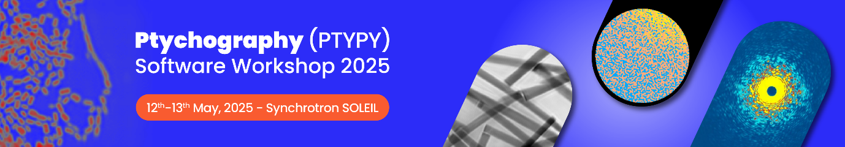
APPLICATION
Identity of the applicant

Last Name: Click or tap here to enter text.
First name: Click or tap here to enter text.
Date of birth: Click or tap here to enter text.
E-mail: Click or tap here to enter text. Tel. Office: Click or tap here to enter text.

Professional identity

You are: ☐ Researcher, Teacher-researcher ☐ Engineer (specify IR, AI): Click or tap here to enter text. ☐ Post-Doctoral researcher ☐ PhD student ☐ Other (specify): Click or tap here to enter text.

Your organisation: ☐ CNRS ☐ University ☐ Other (specify): Click or tap here to enter text.

Name and address of your laboratory: Click or tap here to enter text.
Team: Click or tap here to enter text.
CNRS : Regional Delegation: Click or tap here to enter text. Lab Code: Click or tap here to enter text.

Organisation
Registration fees: €95 VAT included have to be covered by your home institution.

Registration includes lunches, dinners, coffee breaks and accommodation at the SOLEIL Guest house.

Agreement of the team leader (mandatory for PhD students and post-docs)

Name of the team leader: Click or tap here to enter text.
Date: Click or tap here to enter text.
Signature:

Applicant:
Date: Click or tap here to enter text.
Signature :

Motivation for your application

Short description of your activities:
Click or tap here to enter text.

Why do you need this training?:
Click or tap here to enter text.

What do you expect from this training?:
Click or tap here to enter text.

Other motivations:
Click or tap here to enter text.

