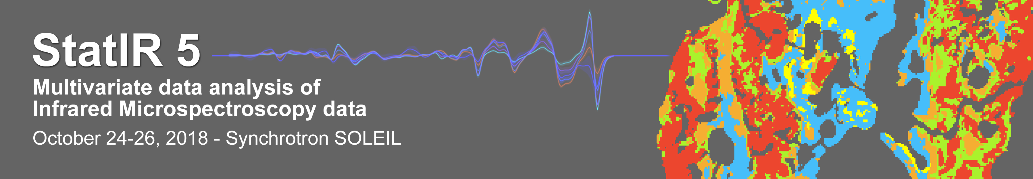

Deadline for registration: September 15, 2018

Personal information
Mr. / Ms. (please delete the wrong mention)
Last name:
First name:

Institution

Adress:

Scientific background
Discipline:
Do you have experience in Infrared micro-spectroscopy?
Do you plan to use SMIS in the future?

Research Interests (biology, chemistry …):

