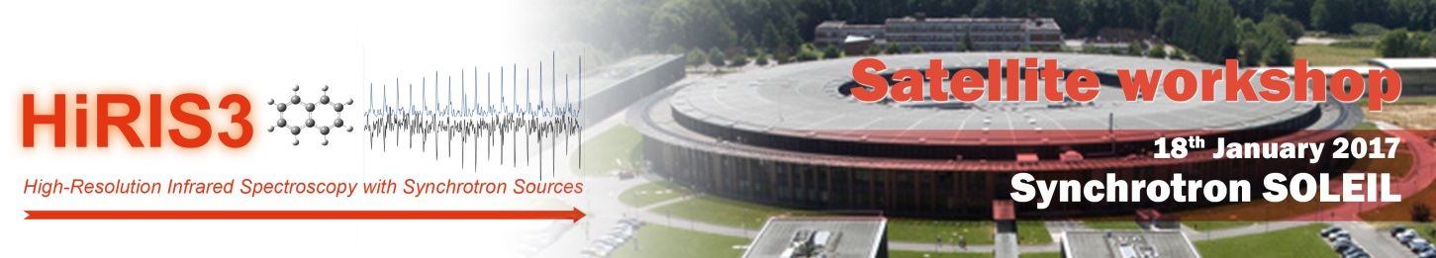

Saint Aubin, 2016

Dear Sir/Madam,

We are pleased to invite your company to participate in HiRIS3 2017: a satellite workshop of the 2017 SOLEIL Users’ Meeting. HiRIS3 (High-Resolution Infrared Spectroscopy with Synchrotron Sources) is a workshop dedicated to High-Resolution Infrared Spectroscopy using Synchrotron Sources. As you know, the AILES beamline at SOLEIL has built specific experimental setups based on some of your products. The aim of this workshop will be to present and summarize the technical and scientific possibilities opened up for Infrared Spectroscopic studies on the AILES Beamline. The expected public includes scientists specialized in the field as well as graduate students in training. The workshop program will provide times for the participants to visit the exhibitors’ booth as well as a visit of the equipment on the Beamline. We think that this constitutes an interesting possibility for your company to interact directly with scientists who will have a potential interest in your products and make them better known to younger future users.
You can find more information regarding the workshop at the HiRIS3 2017 website and we would like to invite you to start planning your participation as an industrial exhibitor or sponsor. Different options are available, which are detailed below. If you wish to join us, please fill in and send in the registration form. For any further inquiries concerning exhibiting at and sponsoring HiRIS3 2017, please contact Conf-HiRIS3-2017@synchrotron-soleil.fr.

We are looking forward to welcoming you in Saint Aubin.

Yours sincerely,

The Organizing Committee

Exhibition and sponsoring information
Deadline January 6th 2017

Companies willing to participate in the industrial exhibition or the sponsoring of the workshop can choose one or several of the following options.
1. Commercial booth at the exhibition, 650 € (excluding VAT)
This offer includes: 1 table (~1.60x0.80 m²), 2 chairs, power supply, one board for commercial posters, 2 attendance fees to the workshop, your company logo and link on the conference website and in the Book of Abstracts and 1 color pages for advertising in the Book of Abstracts (A4 format). Please, note that there will be no paper copy of the book of abstracts, which will be posted on the website.
The company will have to supply the name of the participants, who will be registered in the Invoice/Receipt.
Only one company per table will be accepted.
The attendance fee includes:
- The attendance to all conference sessions;
- Lunch, dinner and coffee breaks
2. Advertising on website and in book of abstracts, 400 € (excluding VAT)
This offer includes: your company logo and link on the conference website and in the Book of Abstracts and 1 color pages for advertising in the Book of Abstracts (A4 format). Please, note that there will be no paper copy of the book of abstracts, which will be posted on the website.

EXHIBITION and SPONSOR REGISTRATION FORM
Fill out the “Exhibition Registration Form” and send it to Conf-HiRIS3-2017@synchrotron-soleil.fr Please note that the number of booths in the exhibition area is limited and will be attributed on a first come, first served basis.

Company name:
E-mail:
Company web site:
Company Address:
City & Country:
Contact person:
Job title:
Phone:
Name of the participant included in the set number 1:
Name of the participant included in the set number 2:
REGISTRATION FOR:
1. Commercial booth at the exhibition (650 € ex. VAT)
2. Advertising on website and in book of abstracts (400 € ex.VAT)

Payment terms

-------- Payment by check --------

Made out to « Synchrotron Soleil » and write back the following reference:
International workshop HiRIS3 2017 / N° 69160603

Thank you for submit your check at the address below accompanied by the registration form:

Synchrotron SOLEIL
Secrétariat HiRIS3 2017
Bureau des Utilisateurs de SOLEIL
L'Orme des Merisiers
Saint Aubin - BP 48
91192 GIF SUR YVETTE Cedex

-------- Payment by bank transfer --------

Thank you for transmit your payment by bank transfer to the following account number:
BNP Paris Bas
International Bank Account Number (IBAN): FR76 3000 4006 8400 0100 8245 430
Code d'identification bancaire (BIC): BNPAFRPPIFO
Synchrotron SOLEIL
with mentioning your name and the workshop reference: International workshop HiRIS3 2017/ N° 69160603
Your registration will be definitive as soon as your payment will be received.

