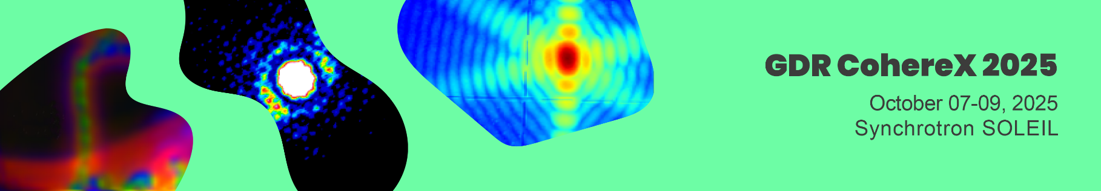

Commercial Exhibitions for companies
Deadline for registration: September 14th, 2025

The research network GDR CohereX will take place from the 7th to the 9th of October 2025, at SOLEIL.

We offer during the event a few exhibition areas to companies interested in presenting their products located in the Hall of the Main building of SOLEIL, giving the opportunity for easy interaction between exhibitors, visitors, attendees and the SOLEIL staff.

The area available, of about 4m², is one table and 4 chairs.

These services are proposed in the 1020,00€ all taxes included (850,00€ without taxes), which includes:

- The exhibition area and a poster panel
- For 2 persons: access to all sessions, the Company’s logo on the web site and the list of Commercial Exhibitors with the Company’s logo into the electronic abstract book, coffee-breaks, the lunches of the 8th and 9th of October and the dinners of the 7th of October 2025 (conference dinner of October 8th is available as an optional extra at €60 inc. VAT).

The exhibitors can also insert an advertising page into the electronic abstract book of the event, for a supplementary 360,00€ all taxes included (300,00€ without taxes) amount.

Please note that the number of booths at the exhibition area is limited, and they will be attributed on a first come first served basis.
Industrial exhibitors are requested to register via online registration. Click here to register.
For any questions, please contact Conf-gdr-coherex2025@synchrotron-soleil.fr

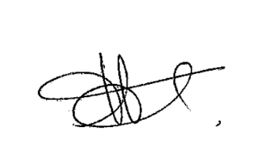
Sincerely yours,

Frederique FRAISSARD
Head, SOLEIL Library and User Office

