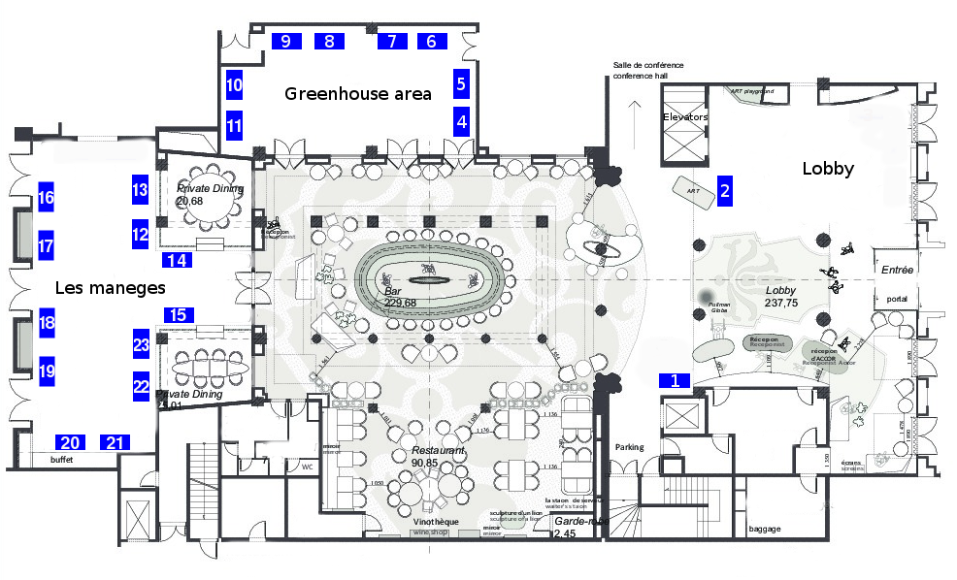
Exhibitor booth plan

Company | Position |  | Company | Position
Arinax Scientific Instrumentation | 10 |  | Malvern Panalytical | 6
Beckman Coulter | 4 |  | Mitegen | 23
Biosaxs GmbH | 18 |  | Molecular Dimensions Anatrace | 20
Bruker AXS | 19 |  | Nanotemper Technologies | 9
Cordouan Technologies SAS | 12 |  | Nano Imaging Services, Inc. | 21
CubeBiotech GmbH | 13 |  | Proteros Biostructures GmbH | 22
Dectris LTD | 5 |  | Rigaku Europe | 7
Domainex | 11 |  | Thermofisher | 1
Formulatrix | 14 |  | TTP Labtech | 16
Global Phasing Limited | 8 |  | Xenocs | 17
Kek Japan | 15 |  | Xtal Concepts Gmbh | 2

